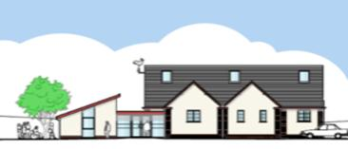
Registered charity no: 300983

HELP KEEP THIS HALL COVID-19 SECURE

1. You must not enter if you or anyone in your household has COVID-19 symptoms.

2. If you develop COVID-19 symptoms within 7 days of visiting these premises alert NHS Test and Trace. Alert the Booking Clerk on
077 1425 6379 and alert the organiser of the activity you attended. You must get a COVID-19 antigen test.

3. Maintain 2 metres social distancing.

4. Use the hand sanitiser provided on entering the premises. Clean your hands often. Soap and paper towels are provided.

5. Avoid touching your face, nose, or eyes. Clean your hands if you do.

6. “Catch it, Bin it, Kill it”. Tissues should be disposed of into one of the bins provided. Then wash your hands.

7. Face coverings MUST be worn unless an exemption applies to a person (eg for health reasons, those aged under 11) or a person has a reasonable excuse not to wear a face covering (eg when taking part in an activity to which an exemption applies). This is a legal requirement.

8. Check the organisers of your activity have cleaned door handles, tables, other equipment, sinks and surfaces before you arrived. Keep them clean.

9. Take turns to use confined spaces such as corridors, kitchen and toilet areas. Standing or sitting next to someone is lower risk than opposite them. Briefly passing another person in a confined space is low risk.

10. Keep the hall well ventilated. Close doors and windows on leaving.

11. Wash your clothes when you get home to reduce risk of transmission.

This hall was last cleaned on : Date: ........................................ at: .......................

shared by Devon Communities Together www.devoncommunities.org.uk V2: 4 July 2020 /
JLW/ 4.7.20/13.8.20/27.8.20.22.9.20/15.10.20

