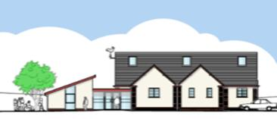
APPENDIX L

Swimbridge Jubilee Hall
Registered charity no: 300983

COVID-19 treatment plan

In the event of someone becoming unwell with suspected COVID-19 symptoms while
at the hall you should:

(a) Send them home immediately

(b) Ask other members of your group to provide their contact details if you do not have them.

(c) Ask the rest of your group to leave the premises, observing the usual hand sanitising and social distancing precautions.

(d) Advise them to launder their clothes when they arrive home.

(e) Inform Swimbridge Jubilee Hall Booking Clerk on 07714 256379

(f) If the unwell person needs to wait for a lift:

1. Remove them to the safe waiting area, which is the Green Room (room at far end of the main hall) – a chair and washing bowl should already be there.

2. Put on a mask, face shield, gloves & apron to protect yourself.

3. Provide them with tissues, a plastic rubbish bag, a bowl of warm water & soap for handwashing & paper towels.

4. Once they have been collected:

(a) Remove gloves, apron and face mask to the rubbish bag. Note that the
waste should be double bagged and kept for 72 hours before being collected.

(b) Leave face shield on top for disinfection.

(c) Wash your hands for at least 20 seconds with warm soapy water.

(d) Phone the Swimbridge Jubilee Hall Booking Clerk on 07714 256379 Wait for her
or a responsible committee member to arrive.

(e) Once home - launder all your clothes and wipe down disinfect your car.

ACRE Information Sheet Opening your village hall after lockdown
shared by Devon Communities Together www.devoncommunities.org.uk/JLW/24.7.20 / 7.8.20 / 27.8.20

